Remodel Plan for Jason Rogalski’s art/science classroom
Style: Vintage Gothic (Yes…I made that up)

Vintage Gothic

I’d like my classroom to feel like you just traveled back to the 17th century’s
“Age of Enlightenment” somewhere in Europe, into the lab of some mad scientist artist. Rainbows will dance across the beautiful walls, snakes will slither in aquariums, strange bubbling sounds come from active experiment areas, as amazing scientific collections lure students through glass.

Red marble floor, glossy black ornate furniture. Deep green Oriental rug in center of the room, with walls painted mahogany with silver science stencils painted on them, such as vast patterns of DNA or other scientific icons. I will make the stencils.

Lots of glass doors & chrome. Several “cabinets of curiosity” will offer collections of bones, soil types & minerals. Here are a couple photos to give an idea of the “feel”, while the actual color scheme will be slightly different…

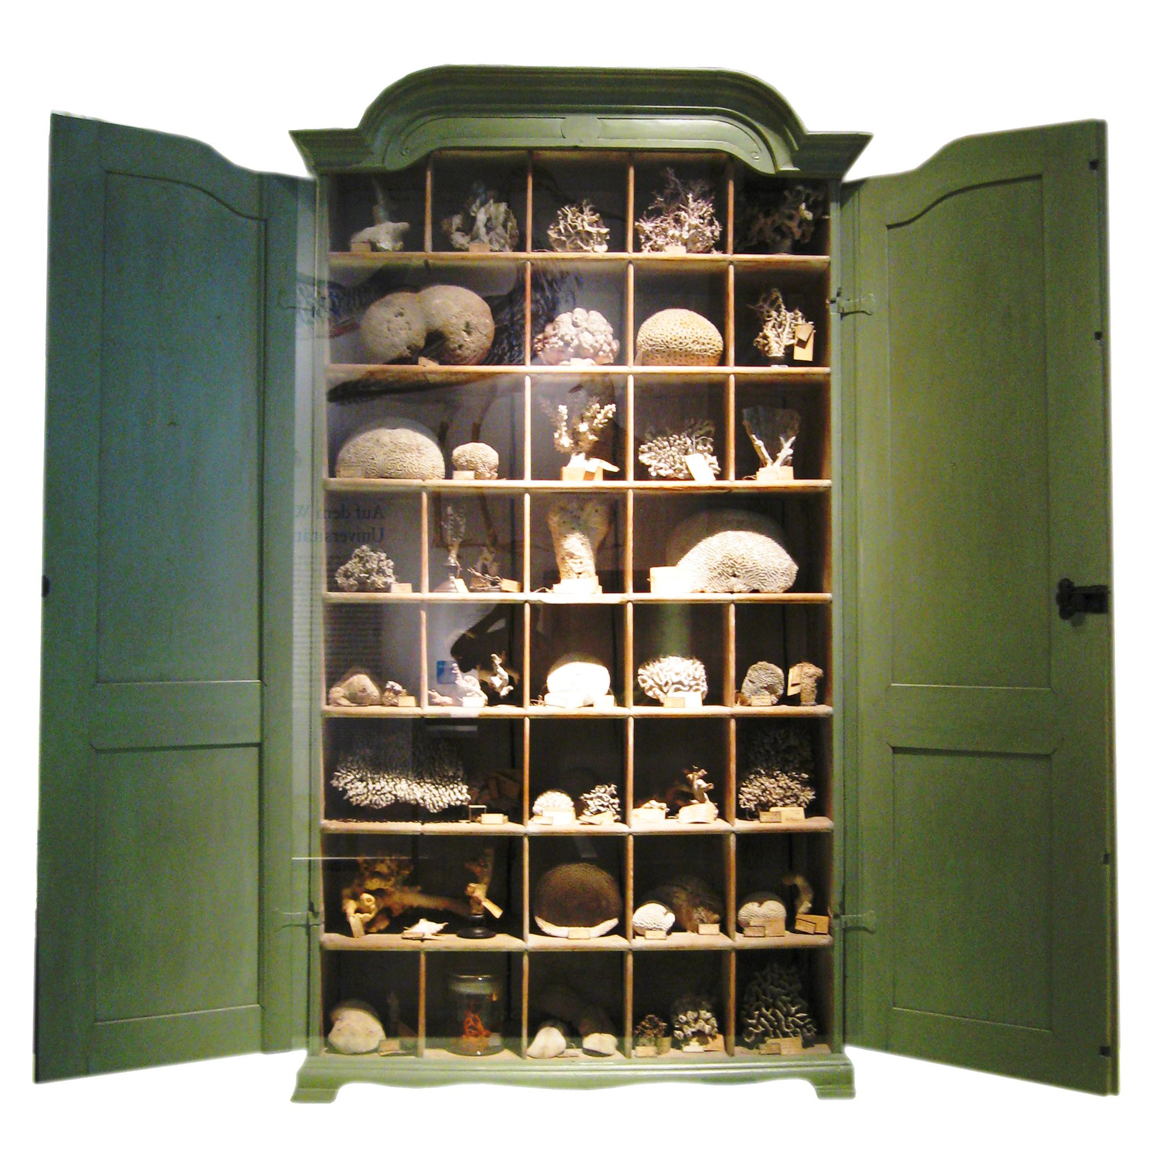

It will “feel” somewhat like this…
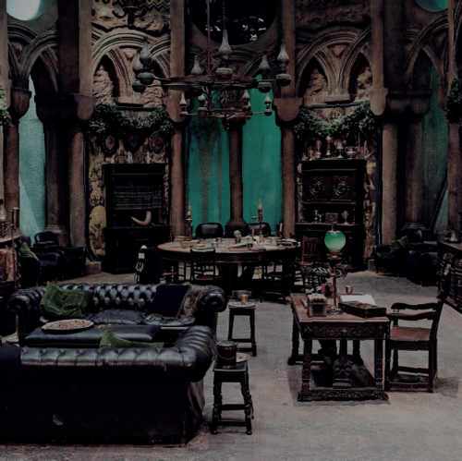

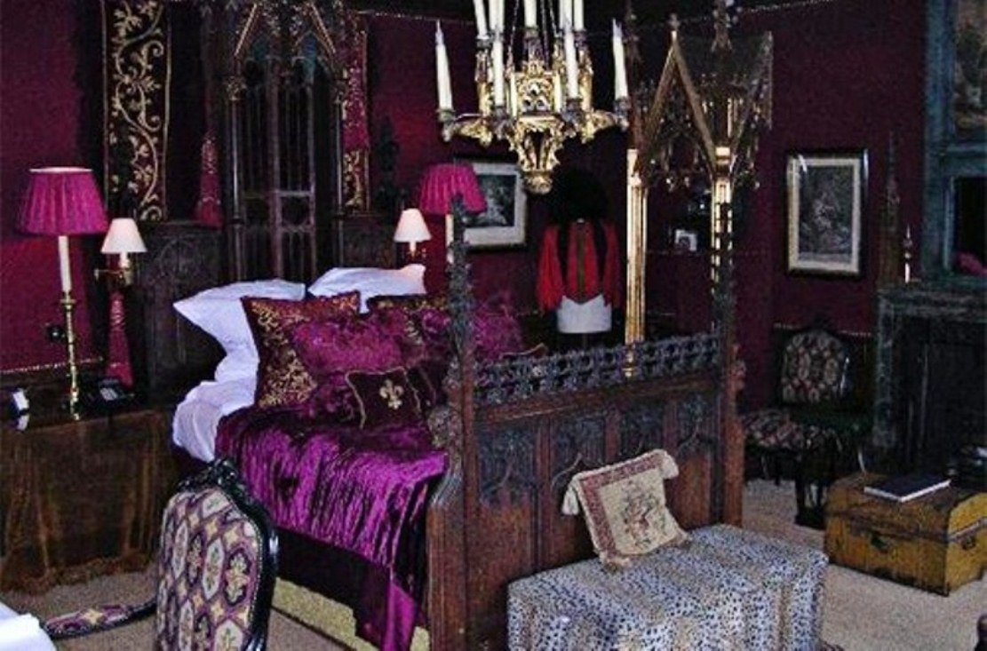

Back wall of black kitchen cabinets. I have access to a laser cutter. I will use this to create the wall stencils, but also ornate science cut outs for the cabinets and window frames.
I will transform cabinets into stuff like this…

Windows will be framed & draped…(I may find some old stain glass too)

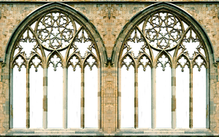

The room will include a drying rack for paintings & clay sculptures.

The back window that gets sun will have a collection of crystals hanging that’ll produce rainbows around the room.
Deep forest velvet green drapes around the windows. A few small painted portraits in fancy gold frames will be hung around the room: Newton, Leonardo Di Vinci, & Tesla. These will be painted by my top art students and the collection will accumulate over the years.

I will repair our old antique wall hanging grandfather clock to replace the existing one.

All of this will attach to our “outdoor lab” which will host a multitude of student led experiments.

Materials List

Back wall of basic black kitchen cabinets
(with new sink & inset methane tank)
Set of super cheesy glass door armoires from thrift shop
Deep forest green drapes for 3 windows (dimensions vary)
1 gallon of glossy black
3 gallons of mahogany paint
a quart of chrome paint
5 sheets of door skin (luan)
3 frilly gold frames (approximately 6-8” D)
3 small & medium cabinets with glass doors from the thrift shop
20 crystals that can be hung
A plasma ball

Proposal: Outdoor Lab
2015-2016

The Need.
I teach several levels & subjects of science at the San Diego Academy. I find that most students learn best when lessons include hand-on-labs. Many of these labs require digging in soil, and other extensive mess making. Other labs require long-term areas, sunlight or sometimes smell too loudly to be done indoors.

I currently solve this problem by doing the activity in my room regardless and making an amazing mess or for other labs, bringing the whole class outside into the garden. I do smoky & stinky demonstrations there, but worry that students may trip if they try to move to quickly. We do various lab activities in the garden, but end up digging up the garden that other students work hard to maintain. Long-term projects sometimes are disturbed as other people from the church visit on the weekends.

The Solution.
The front door of my classroom opens to a large front yard. Currently, neither our school, nor the church is using this land. Several neighbors use it to relieve their dogs daily. We pay for this space, but it is not being utilized.

This yard should become our outdoor lab. It would only require a fence to keep out the public and some plants to provide privacy for our classes as they work there. It is perfectly located as it directly adjoins our science class.

My Vision.
Here are a few examples of projects that I’d like to use our outdoor lab for. Some will be immediate, while others will require some time, funding & energy to arrange.

Grafting Experiments-We will study & try grafting of several plant types: cactus, rose, tomato and/or citrus tree experiments. Imagine a tree growing oranges, lemons & limes, Frankenstein cacti & multicolored rosebushes.
Time & Astronomy-Students will attempt to create a sundial. This will be photographed over the course of the year to understand minor or major cycles.
Ecosystem Logs-A set of rotting logs will be considered a sanctuary & be seeded with moisture. I will release local insects and lizards under them. Students will turn over the logs during lab to collect & analyze survival methods & systems such as niche, predator & prey, & parasites. This lab was a favorite in Alpine.
Mud Boards-As we study erosion, students will work in teams to pack an inch of soil entirely covering a 2’x4’ board. They carve a meandering streambed into the length of it and deposit a series of erosion experiments at the various curves, such as; salt, sand, root clumps, clay & stone. They rain set amounts of water at the top & make observation.
Aquaponics Pond-A very small pond will act to illustrate the importance of the nitrogen cycle as we grow plants fueled by fish waste as the same plants clean the water for the fish. This will be an expansion of the tank we’ve ran in the office over the last two years.
Volcano Models-Students will have sufficient room to build their volcano models that explode with Mentos & soda pop.
Composting-Students will learn how composting works as we actually do it.
Erosion Sculptures-Students will make a set of sculptures from a variety of materials to see how they weather over a year in the sun, wind & rain.
Culturing Protists-We will collect some water from Chollas Lake. This will be in a bucket with some egg yoke & flour. Microscopic organisms will multiply and we can observe several species swimming around in our microscopes, without stinking up the classroom.
Cross-pollination Experiments-As we study genetics, we can follow in the steps of Gregor Mendel as we cross pollinate red flowering pea plants with white flowing pea plants to learn about dominate & recessive traits.
Carnivorous Plants Greenhouse-A small greenhouse area will work to nurture venus flytraps, pitcher plants & sundews.
Demonstration Area- a platform with space around it to do fantastic demos such as the ammonium dichromate combustion or the Black Cobra with room for students to easily move away from smoke.
Weather Station-This will be for our study of meteorology (weather) and will include several simple tools to collect data over the year.
On-going Individualized Plant Experiments- Each student will have their own on-going plant experiment that they collect data on. Each will be different.
Solar energy-We will attempt to build solar powered devices. One may run the aquaponics pump.

These are just a few activities that might occur in our outdoor lab.

What am I asking for “exactly”?
5 foot wood Fence with locking gate.
Start-up costs for an outdoor cabinet
Small pond
weather station
greenhouse
worktables
shed
and other supplies.

Locking Shed- A locking shed will act as a valuable storage area for many inexpensive, but space consuming supplies used in science & art.

Total Materials & Expenses (approximately)
Back wall of basic black kitchen cabinets (Ask Antonina)
(with new sink & inset methane tank) …(Ask Antonina)
Set of super cheesy glass door armoires/dressers from thrift shop ($200)
Used Oriental throw rug ($100)
Drying rack ($150)
Deep forest green drapes for 3 windows ($75)
1 gallon of glossy black($20)
3 gallons of mahogany paint($60)
a quart of chrome paint($30)
5 sheets of door skin (luan) ($65)
3 frilly gold frames (approximately 6-8” D) ($30)
3 small & medium cabinets with glass doors from the thrift shop ($60)
20 crystals that can be hung ($60)
A plasma ball($20)
5 foot wood Fence with locking gate. (Ask Antonina)
Start-up costs for an outdoor cabinet ($50)
Small pond with pump($200)
weather station ($100)
greenhouse ($250)
3 outdoor worktables ($75)
Locking Shed (free…it is behind Alpine Academy…I can go get it.)
and other supplies (unexpected supplies & costs $300)

Total-$1905++ unknowns (Ask Antonina)

